# Laboratory 9

1. Questions
2. Write a C program to construct a binary search tree and perform the Preorder, post order and in order traversal.
3. Write a C program to implement a linked list to construct a tree and count the number of leaves in a tree.
4. Algorithm

**2.1 C program to construct a binary search tree and perform the Preorder, post order and in order traversal.**

Step1: start

Step2: Inorder(tree)

1. Traverse the left subtree, i.e., call Inorder(left-subtree)

2. Visit the root.

3. Traverse the right subtree, i.e., call Inorder(right-subtree)

Step3: Preorder(tree)

1. Visit the root.

2. Traverse the left subtree, i.e., call Preorder(left-subtree)

3. Traverse the right subtree, i.e., call Preorder(right-subtree)

Step4: Postorder(tree)

1. Traverse the left subtree, i.e., call Postorder(left-subtree)

2. Traverse the right subtree, i.e., call Postorder(right-subtree)

3. Visit the root.

Step5: call the function accordingly in the main body

Step6: stop

1. **2.2** C program to implement a linked list to construct a tree and count the number of leaves in a tree.

Step 1: start

Step 2: allocate node

Step 3: put in the data

Step 4: push data into a linked list

4.1 if (head == NULL):

4.2 head = temp;

4.3 head->next = NULL

4.4 else: temp->next= head and head = temp

Step 5: print the linked list

Step 6: allocate a newtreenode

6.1 temp ->info=value

6.2 emp->count = 0;

6.3 temp->left= temp->right = NULL;

Step 7: insert function

7.1 if root=NULL: return newtreenode(key)

7.2 if root->left = NULL: root->left = newTreeNode(key);

7.3 if root->right = NULL: root->right = newTreeNode(key);

7.4 if (temp->count! =2): insert(root->left,key);

else {

temp = root->right;

7.4.1 if (temp->count! =2)

insert(root->right,key);

7.4.2 else

insert(root->left,key);

7.5 return root

Step 8: Step 8: for getting leaf count

8.1 if(root == NULL) : return 0;

8.2 if(root->left = NULL && root->right = NULL):return 1;

8.3else

Return LeafCount(root->left)+LeafCount(root->right);

Step 9: stop

1. Program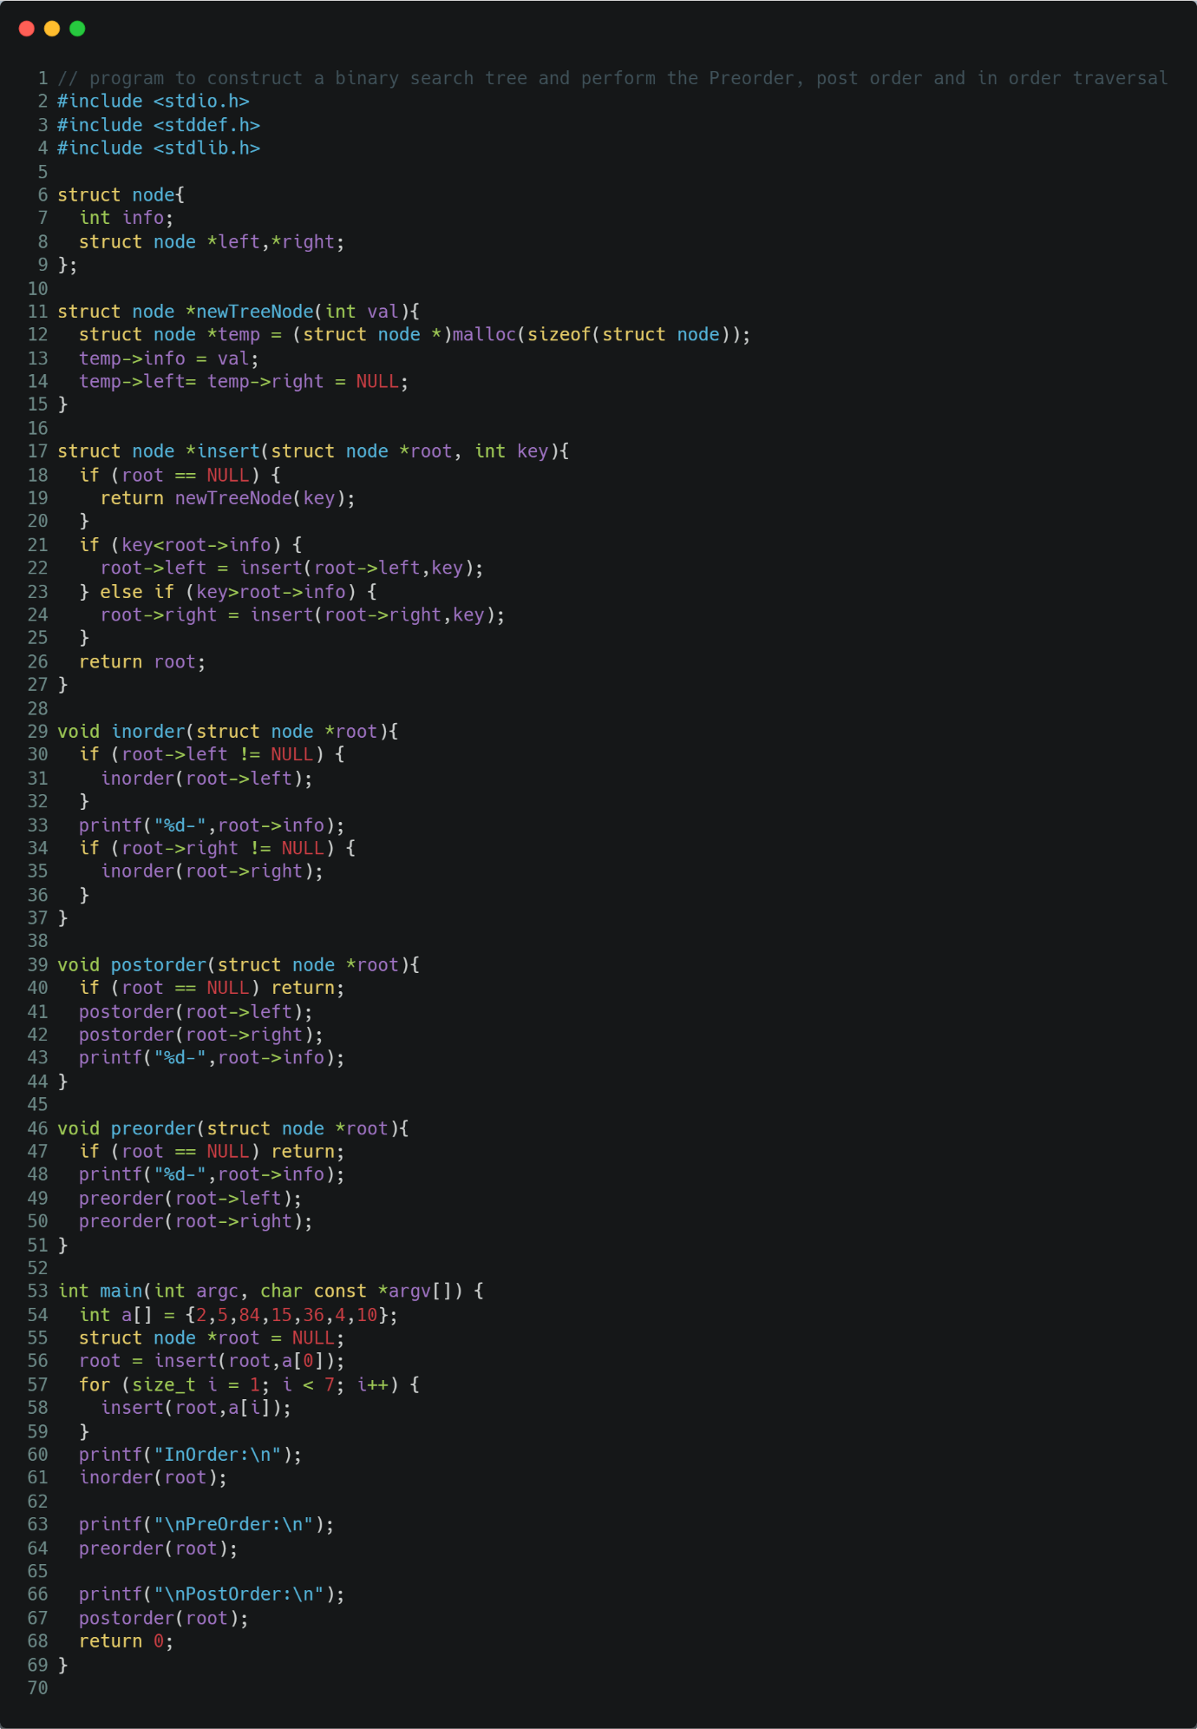

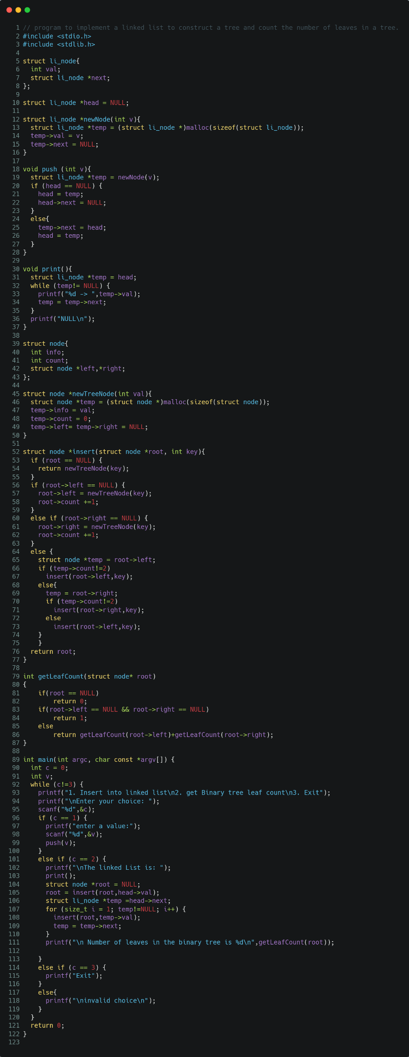

1. Presentation of Results

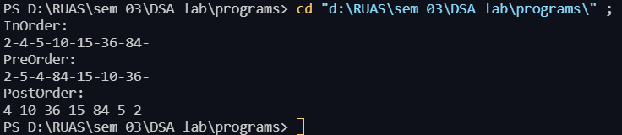

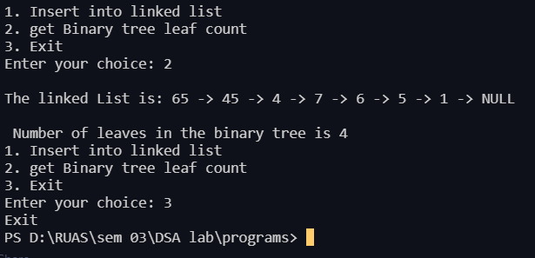

1. Conclusions

Learning happened

trees are hierarchical data structures.

The topmost node is called root of the tree. The elements that are directly under an element are called its children. The element directly above something is called its parent.

Binary Tree: A tree whose elements have at most 2 children is called a binary tree. Since each element in a binary tree can have only 2 children, we typically name them the left and right child.

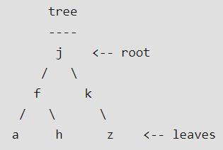

Binary Search Tree, is a node-based binary tree data structure which has the following properties:

* The left subtree of a node contains only nodes with keys lesser than the node’s key.
* The right subtree of a node contains only nodes with keys greater than the node’s key.
* The left and right subtree each must also be a binary search tree.